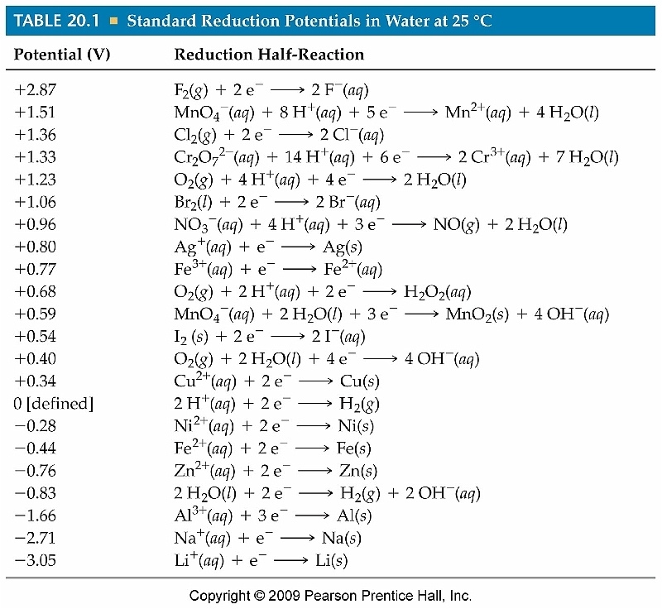 ΔG = ΔG° + RT Ln Q ℰ = ℰ° − 0.0592log Q ΔG = −n F ℰ
n
F =96500 coul/mol e-
______5. Which of the following is the strongest reducing agent? A) Al B) Ni C) Zn
D) Fe ²⁺

______6. What is the standard electrical potential, ℰº, for the reaction
Zn + 2 Ag⁺_{(aq)} → Zn²⁺_{(aq)} + 2 Ag ?
A) 1.56 volts B) 2.36 volts C) 0.040 volts D) –0.040 volts

______9. Given that the standard potential for the reaction
Pb(s) + 2 Ag⁺(aq) → 2 Ag(s) + Pb²⁺(aq) is 0.93 volts, what is the standard reduction potential of Pb²⁺ ?

________18. Which of the metals listed below, will NOT react spontaneously
with 1.00 molar HCl ? A)Zn B) Na C) Ag D) Al

III. Balance in acidic media: Show both balanced half reactions, and indicate which is the oxidation. MnO₄– (aq) + CH₃OH (aq) → Mn²⁺(aq) + HCOOH(aq)

IX. A standard chemical cell is constructed using 1.00 molar solutions of Ni(NO₃)₂ and Zn(NO₃)₂ , zinc metal, and nickel metal.

A. Draw a labeled diagram of the cell. Indicate on your diagram
1. the direction of electron flow through the connecting wire
2. The + pole
3. The cathode
( 6 pts)

B. (answer “increases,” “decreases” or “remains the same.”
( 4 pts)
1. When additional solid Ni(NO₃)₂ is dissolved in the nickel half cell,
the voltage _____________________
2. If the size of the zinc electrode is increased, the voltage _______________

C. Write a balanced equation for the reaction that occurs in this cell. ( 2 pts)

D. Find Eº for the cell, in volts. ( 2 pts)

E. Find ΔGº for the reaction you wrote in part C. ( 2 pts)

F. Find the voltage produced by this cell when the Zn²⁺ is 1.99 molar, and the
[Ni²⁺] is 0.0100 molar ( 3 pts)

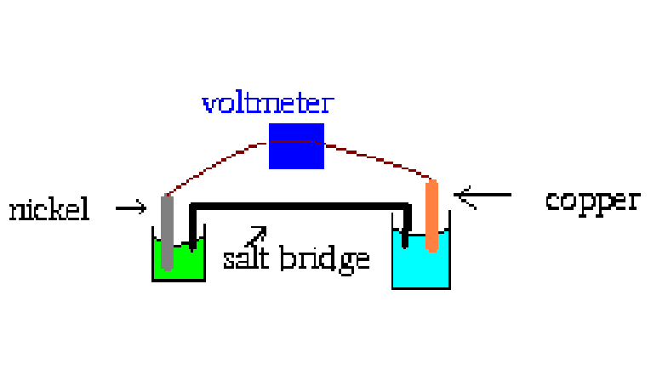

Nickel is immersed in Ni²⁺, 1 molar solution, ( Ni(NO₃)₂ and the Cu in 1 M Cu²⁺ ( Cu(NO₃)₂
Draw an arrow indicating the flow of electrons. Draw another indicating the movement of the + ions in the salt bridge. As this cell runs, one of the colors gets deeper, and the other paler. Why?

