Sample AP chemistry test II.

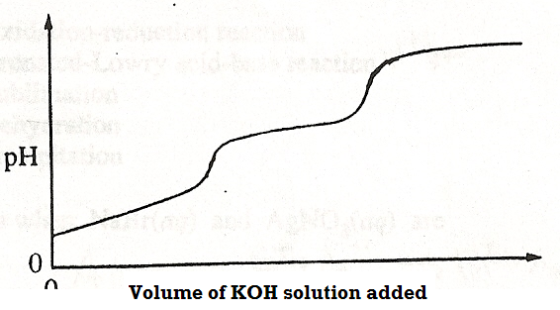

1. An unknown acid was titrated with KOH solution. The pH was constantly monitored, and the resulting titration curve was plotted, as shown above. Which of the following acids is most likely to be the unknown acid?

A) CH₃COOH B) HCl C) HCOOH D) HNO₃ E) H₂C₂O₄

Questions 2 – 5 refer to the following salts.

A) K₂SO₃ B) BaSO₄ C) Ca(NO₃)₂ D) NaHCO₃ E) Na₂CrO₄

2) Is often used in baking, and as a remedy for indigestion

3) May be used as a reducing agent

4) Reacts with HCl to form a colorless, odorless gas

5) Is the least soluble in water

Questions 6-8.

A) Standard enthalpy change B) Standard free energy change
C) Standard entropy change D) Equilibrium constant
E) Work

6) Can have an extremely small, fractional value, but never a negative value

7) MUST have a negative value for an exothermic reaction

8) May be calculated from the standard electrode potential, Eº , even if the temperature
is unknown
Questions 9-11 refer to the following potential energy diagram for the uncatalyzed reaction represented below.

SO₂(g) + NO₂(g)  NO(g) + SO₃(g)

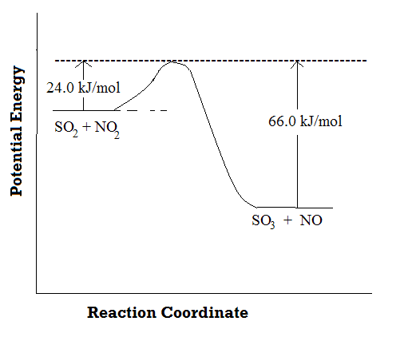
A) –42.0 kJ/mol B) +90.0 kJ/mol C) + 24 kJ/mol

D) +66.0 kJ/mol E) Positive, but less than 24.0 kJ/mol

9. The energy of activation for the catalyzed forward reaction

10. The energy of activation for the uncatalyzed reverse reaction

11. The change in potential energy for the reaction
SO₂(g) + NO₂(g)  NO(g) + SO₃(g)

12. 2 NO₂(g)  N₂O₄(g). When the system represented by this equation is at equilibrium at a certain temperature, the partial pressure of NO₂ is 1.5 atm, and the partial pressure of N2O4 is 0.50 atm. What is the value of the equilibrium constant, K_{p}, at this temperature? A) 0.15 B) 0.22 C) 0.33 D) 3.0
E) 4.5

13. The base dissociation constant, Kb, of HONH₂ is 1.1 × 10⁻⁸ . The pH of a
1.0 M aqueous solution of HONH₂ is closest to
A) 4.0 B) 6.0 C) 8.0 D) 10.0 E) 14.0

14. Which of the following aqueous solutions has the lowest freezing point?
A) 0.10 m K₃PO₄ B) 0.20 m Na₂SO₄ C) 0.20 m KI
D) 0.30 m C₆H₁₂O₆ E) 0.10 m Ni(NO₃)₃

Questions 15 – 16 refer to the graph below, which shows the temperature of a pure substance as a function of time, as the sample is cooled at a constant rate at constant pressure. The sample is initially a gas.

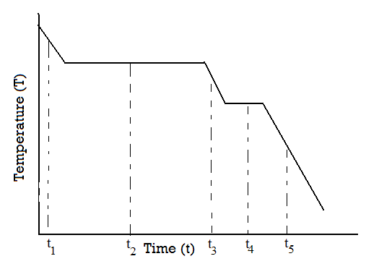

A) t₁ B) t₂ C) t₃ D) t₄ E) t₅

15. Time when the subtance is at its normal boiling point

16. Time when both the solid and the liquid phases are present

17. A small increase in temperature often produces large increase in reaction rate. Which best accounts for this increase in rate?
A) There is a decrease in the activation energy of the reaction
B) There is an increase in the activation energy of the reaction
C) There is an increase in the number of high energy molecular collisions
D) There is a decrease in the rate constant for the reaction
E) There is an increase in the total frequency of molecular collisions

18. Which of the following best describes all of the bond types in the bonding between
atoms in a nitrogen molecule? A) 3 σ bonds B) 3 π bonds
C) one σ and two π bonds D) two σ and one π bond
E) one σ, one π, and one θ .

A(s) + 2 B (g) ➞ 3 C(s) ΔH°rxn = + 39 kJ

A(s) + 2 B (g) ➞ 3 D (l) ΔH°rxn = –39 KJ

19. In the basis of the information above, what is the value of ΔH°rxn for the following reaction: C(s) ➞ D(l)
A) –78 Kj B) –234 kJ C) –26 kJ D) –39 kJ E) 0 kJ

20. A and B are volatile substances. When they are mixed so that the mole fraction of A is 0.400, they form an ideal solution with a vapor pressure of 160 mm Hg. If the vapor pressure of pure A is 100. mm Hg, what is the vapor pressure of pure B?
A) 60.0 mm Hg B) 120 mm Hg C) 96.0 mm Hg D) 200 mm Hg
E) 300. mm Hg

2 Al(s) + 6 H⁺(aq) ➞ 2 Al³⁺(aq) + 3 H₂(g)

21. The mass of aluminum needed to react completely with 250 mL of 2.0 M HCl as shown in the equation above is A) 4.5 g B) 9.0 g C) 18 g
D) 27 g E) 54 g

22. A student used a 0.1500 molar NaOH solution to titrate three 25.00 mL samples of
a solution of hydrochloric acid. The volumes of base used for the three titrations were 32.65 mL, 32.61 mL and 32.64 mL. Which statement about the experiment is evidently true? A) The precision is poor, but the accuracy is excellent
B) The precision is good, but the accuracy cannot be evaluated from the given information. C) The accuracy would be better if a more concentrated NaOH solution were used D) All three titrations have the same amount of error
E) Precision will improve if more titrations are done

23. In the Lewis structure of an SF₄ molecule, how many unshared pairs of electrons are there around the S atom? A) none B) one pair C) two pairs
D) three pairs E) four pairs

Questions 24 to 26 refer to the following chemical or physical changes

A) Precipitation B) Sublimation C) Condensation
D) Brönsted-Lowry acid-base reaction E) Oxidation-reduction reaction

24. Occurs when KI(aq) and AgNO₃(aq) are mixed

25. Occurs when an aqueous solution of hydrogen chloride is added to an aqueous solution of ammonia

26. Occurs when solid sodium carbonate, Na₂CO₃, is added to water

27. The Ka of HC₂H₃O₃ is 1.8 × 10⁻⁵. Using only 0.10 M solutions of HC₂H₃O₂ and NaC₂H₃O₂, a solution of pH = 7 can be prepared by
A) Mixing equal volumes of the two solutions
B) Using more of the HC₂H₃O₂ solution than the NaC₂H₃O₂ solution
C) Using less of the HC₂H₃O₂ solution than the NaC₂H₃O₂ solution
D) Using only the HC₂H₃O₂
E) Using only the NaC₂H₃O₂

28. Which of the following is the best piece of glassware for preparing 500.0 mL of an aqueous solution of a solid? A) Burette B) Erlenmeyer flask
C) Volumetric flask D) Test tube E) Graduated cylinder

29. A 44.0 gram sample of a pure gaseous compound occupies 44.8 liters at 273 K and
380 mm of Hg. The molar mass of the gas, in grams per mole, is
A) 11 B) 22 C) 44 D) 88 E) 176

30. NH₃(aq) + H₂SO₄(aq) ➞ NH₄⁺(aq) + HSO₄–(aq)

The Brönsted-Lowry bases in the reaction above are

A) NH₃ and HSO₄– B) NH₃ and NH₄⁺ C) H₂SO₄ and NH₄⁺
D) H₂SO₄ and HSO₄– E) NH₃ and H₂SO₄

31. A metal cube measures 2.20 cm on each side, and has a mass of 117.30 g. On the basis of this data, the value for the density of the metal is best reported as
A) 11.016 g/cm³ B) 11.02 g/cm³ C) 11.0 g/cm³ D) 11 g/cm³
E) 11.0162 g/cm³

32. When magnesium is added to dilute sulfuric acid, which of the following gases is
produced? A) H₂ B) O₂ C) H₂S D) SO₃ E) MgS

33. The molecular geometry of SiCl₄ is A) seesaw B) tetrahedral
C) trigonal pyramidal D) trigonal bipyramidal E) square planar

34. For which of the following reactions is ΔS° negative?

A) CaCO₃(s) ➞ CaO(s) + CO₂(g) B) I₂(s) ➞ I₂(g)

C) 2 HI(g) + Cl₂(g) ➞ 2 HCl(g) + I₂(s)

D) 2 NO₂(g) ➞ N₂(g) + 2 O₂(g)

E) C₂H₅OH(l) ➞ C₂H₅OH(g)

35. Of the following species, which contains only single bonds?
A) N₂H₄ B) NO₃– C) NO₂– D) CO₂ E) N₂

36. Which of the following would be most useful in developing a reaction mechanism?
A) Rate order of the reaction B) Rate constant of the reaction
C) Catalyst D) Activation energy E) Free energy change

Questions 37 – 38.

Pb²⁺ (aq) + 2 e– = Pb(s) E° = –0.126 V
Ag⁺ (aq) + e– = Ag(s) E° = +0.799 V

A galvanic cell is made by a combination of the half cells listed above.

37. The standard cell potential of this galvanic cell is A) 0.673 V B) 0.925 V
C) 1.05 V D) 1.34 V E) 1.85 V

38. When all of the species are in the standard state, the reaction at the cathode of the galvanic cell is A) Ag(s) ➞  Ag⁺(aq) + e– B) Ag⁺(aq) + e– ➞Ag(s)
C) Pb(s) ➞ Pb²⁺(aq) + 2 e– D) Pb²⁺(aq) + 2 e– ➞ Pb(s)
E) Pb²⁺(aq) ➞ Pb⁴⁺(aq) + 2 e–

39. An atom of nitrogen-13 decays by emitting a positron. The nucleus produced contains which of the following? A) 6 protons and 7 neutrons
B) 7 protons and 6 neutrons C) 8 protons and 5 neutrons
D) 7 protons and 7 neutrons E) 6 protons and 8 neutrons

40. Which of the following statements about atoms is incorrect?
A) Atoms are neutral because they contain the same number of protons and electrons
B) All atoms of a given element must contain the same number protons, electrons, and neutrons. C) Most of the volume of an atom contains only electrons
D) The nucleus is positively charged
E) Almost all of the mass of an atom is in the nucleus

41. Resonance structures are NOT used to represent the bonding in which of the following species? A) O₃ B) C₂H₂ C) CH₃COO– D) C₆H₆ E) CO₃^{2–}

42. The boiling points of hydrocarbons that have large molecular masses are relatively high mainly due to A) the presence of unsaturated carbon atoms
B) strong carbon-carbon bonds C) strong interionic attractions
D) hydrogen bonding E) London (dispersion) forces

43. Equal volumes of a 0.10 M Ca(NO₃)₂ solution and 0.20 M NaNO₃ solution are mixed.
The molarity of nitrate ion, [NO₃–], in the resulting solution is
A) 0.05 M B) 0.10 M C) 0.15 M D) 0.20 M E) 0.30 M

44. When heated, metallic carbonates generally produce
A) Metal oxides and carbon dioxide B) metals, CO, and O₂
C) metal oxalates and O₂ D) metal hydroxides and CO₂
E) Metal peroxides and CO

45. Which of the following indicators is most appropriate for use in the titration of
0.10 M NH₃ with 0.10 M HNO₃ ?
A) Methyl violet pKa = 1
B) Methyl red pKa = 5
C) Bromecresol blue pKa = 7
D) Cresol red pKa = 9
E) Alizarin yellow pKa = 11

46. A weak electrolyte is a substance that
A) is only slightly dissociated into ions in solution
B) does not dissociate into ions in solution
C) is only slightly soluble in water
D) is easily decomposed by electricity
E) has weak bonds in its molecules

47. Ksp = [Pb²⁺][I–]² The solubility product constant of PbI₂ is 1 × 10⁻⁸ . In a solution of KI that is saturated with PbI₂, the concentration of iodide ions is 1 x 10^{–3} M. What is the concentration of lead ions in this solution?
A) 1 × 10⁻¹¹ M B) 1 × 10⁻⁸ M C) 1 × 10⁻⁵ M D) 1 × 10⁻³ M E) 1 × 10⁻² M

48. When 63.5 g of iodine and 12.2 g of antimony are dissolved in a suitable solvent and heated, antimony (III) iodide, SbI₃ is formed. How much product is obtained when the reaction goes to completion? A) 0.0500 mol B) 0.100 mol
C) 0.150 mol D) 0.300 mol E) 0.500 mol

49. Which of the following provides the best evidence that RbBr is an ionic solid?
A) It conducts electricity when melted B) It is crystalline
C) It melts at 695°C D) It is more soluble in water than it is in benzene
E) It is a white solid.

50. The density of CO₂ gas (molar mass=44 g) at 0°C and 0.5 atm is closest to
A) 0.5 g/L B) 1 g/L C) 2 g/L D) 4 g/L E) 5 g/L

51. MnO₄–(aq) + NO(g) + H⁺(aq) ➞ NO₃– + Mn²⁺(aq) + H₂O_{(l)}

When this equation is balanced with lowest whole-number coefficients, the coefficient of the H⁺(aq) is A) 2 B) 4 C) 8 D) 14 E) 28

52. Which of the following compounds is least soluble in water at 25°C?
A) CH₃OH, methanol B) C₈H₁₈, octane C) K₂SO₄ , potassium sulfate
D) AgNO₃, silver nitrate E) NaCl, sodium chloride
53. Which of the following substances is characterized by nonpolar molecules?
A) H₂O(l) B) KBr(s) C) HBr(g) D) NH₃(g) E) CH₄(g)

54. Which of the following units of concentration may change with temperature?
A) Mole fraction B) Molarity C) Molality D) Weight percentage
E) Mole percentage

55. A salt sample is being analyzed to determine the percentage by weight of sulfate. All of the following are appropriate steps in a procedure to perform this determination except A) determine the mass of the sample to be analysed
B) add excess barium chloride solution to a solution of the sample
C) collect the barium sulfate formed on a paper filter
D) measure the volume of water from which the barium sulfate precipitate is removed
E) determine the mass of the barium sulfate formed

Questions 56-57 refer to the typical one component phase diagram shown below.
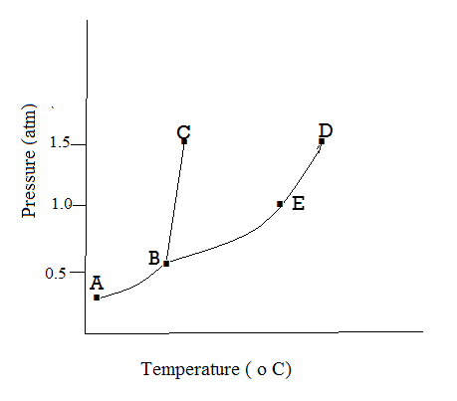
56. The normal boiling point is indicated by point A)A B)B C)C D)D E)E

57. The solid, liquid, and gas phases can exist in equilibrium at conditions corresponding to which of the following? A) point A only B) point B only
C) point C only D) all points on the curve between A and B
E) all points on the curve between B and D

58. The heat of formation of propane, C₃H₈(g), is by definition the enthalpy change of which reaction? A) C₂H₄(g) + CH₄(g) ➞ C₃H₈(g)
B) 3 C(g) + 8 H(g) ➞ C₃H₈(g) C) 3 C(s) + 8 H(g) ➞ C₃H₈(g)
D) 3 C(s) + 4 H₂(g) ➞ C₃H₈(g) E) C₂H₆(g) + CH₄(g) ➞ C₃H₈(g) + H₂(g)

59. N₂O₅(g)  2 NO₂(g) + ½ O₂(g) The equilibrium constant for this reaction is
95 at 25°C. What is the value of the equilibrium constant at that temperature for the following reaction? O₂(g) + 4 NO₂(g)  2 N₂O₅(g)

A) (95)² B) 95 C) (95)^{–1} D) (95)^{–2} E) (95)^{0.5}

60. Oxygen is reduced in all of the following reactions except
A) 2 C + O₂ ➞ 2 CO B) S + O₂ ➞ SO₂

C) 2 F₂ + O₂ ➞ 2 OF₂ D) 2 Na + O₂ ➞ 2 Na₂O₂

E) 2 Mg + O₂ ➞ 2 MgO

61. 2 KOH + Cl₂ ➞ KClO + KCl + H₂O

3 KClO ➞ KClO₃ + 2 KCl

4 KClO₃ ➞ 3 KClO₄ + KCl

KClO₄ can be prepared from KOH and Cl₂ by the series of reactions shown above. How many moles of KClO₄ can be prepared from 1 mole of Cl₂ and excess KOH?

A) 1/4 B) 1/3 C) 1 D) 3 E) 4

62. Which of the following 0.1 M solutions is colorless?
A) MgCl₂ B) Ni(NO₃)₃ C) Na₂CrO₄ D) KMnO₄ E) CuSO₄

63. 2 Ca(s) + O₂(g) ➞ 2 CaO(s).
The standard enthalpy of formation, ΔH°_{f} for CaO is –600 kJ per mole. How much heat is liberated at 298 K when 5 grams of Ca reacts with excess oxygen gas to form CaO ? A) 1200 kJ B) 3000 kJ C) 75 kJ D) 150 kJ E) 38 kJ

64. If 50. mL of 1.0 M KOH is diluted with water to a final volume of 2.0 liters, the concentration of the resulting solution is A) 0.025 M B) 0.050 M C) 0.10 M
D) 0.50 M E) 1.0 M

65. The molar mass of compound A is 16 g; that of compound B is 64 g. What is the ratio of the rate of effusion of A to that of B?
A) 4 to 1 B) 1 to 4 C) 2 to 1 D) 1 to 2 E) 8 to 1

66. If the pressure applied to 1.0 liter of a gas is doubled while the Kelvin temperature is tripled, the new volume of the gas will be A) 1.0 liter B) 0.50 liter
C) 0.67 liter D) 1.5 liters E) 3.0 liters

67 to 69. Two 10.0 liter vessels, are filled with gases at the same temperature. Vessel A contains 32.0 grams of O₂ gas, while vessel B contains 32.0 grams of CH₄ gas.

A) 1:1 B) 1:2 C) 2:1 D) 1.4:1 E) 1:1.4

67. The ratio of the densities of the gas in vessel A to the gas in vessel B.

68. The ratio of the pressures of the gas in vessel A to the gas in vessel B.

69. The ratio of the average kinetic energies of the gas in vessel A to the gas in vessel B.

70. The addition of a small volume of a 0.10 M solution of strong acid or strong base has very little effect on the pH of a solution containing equimolar concentrations of
A) NaH₂PO₄ and Na₂HPO₄ B) NaOH and NaCl C) HCl and NH₃
D) H₂SO₄ and Ba(OH)₂ E) K₂CO₃ and Na₂CO₃

71 to 73 are based on the following compounds of sulfur:

A) NaHSO₄ B) SO₂ C) Na₂S D) K₂S₂O₃ E) PbS

71. Which dissolves in water to produce a basic solution that gives a yellow flame test?

72. In which of these does sulfur have the highest oxidation state?

73. Which is relatively insoluble in water?

74. Which of the following ions has the largest radius?
A) S^{2–} B) Cl– C) K⁺ D) Ca²⁺ E) O^{2–}

75. The geometry of an SO₃ molecule is best described as
A) trigonal pyramidal B) T shaped C) trigonal planar
D) tetrahedral E) linear

